Show the world the lovely, diverse, friendly team behind your Doughnut Economics group!
- Create a montage of group members posing with their individual, hand-crafted doughnuts
- If you’re shy, you can still take part! Hide your face behind the doughnut if that's more comfortable for you :)

1. Make your own giant doughnut  - Print page on A4, and back with cardboard  - Cut out along the lines  - Glue or paint in colourful toppings | 2. Take a selfie  - Portrait format, and more than one would be great  - Smile, head and shoulders, doughnut out front or side  - Pose how you want – frame face, peek through, bite!

3. Share your selfie with us
- Bonus: say what you like to be called, and why you got involved with the project and why it’s important to you

About this doughnut template
Make a Doughnut Selfie - create your own personal doughnut to pose with for pictures. A fun idea for photos of the members of your local Doughnut Economics group for your website, or presentations, or publicity materials.

Top tips:
- You do not have to use the template for the photos, you can pose with an actual doughnut (with a hole in the middle) or any other prop that is doughnutty. Like a bagel. Yeah bagels work.
- Hold your doughnut closer to the camera lens to make it look GIANT.

Here’s video instructions to make a doughnut.
https://www.youtube.com/watch?v=v5JjoAgQ6Us&feature=youtu.be

Here are some of the Cambridge Doughnutters!
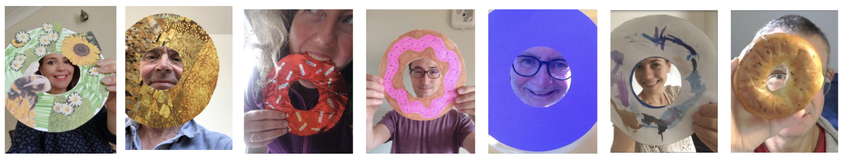

Psst - If you do use this idea, it would really please me to know how, and see your lovely faces too. drop a line to
info@cambridgedoughnut.org.uk. Thanks!

